programming languages
A programming language is formal system of rules and syntax used to write instructions that a computer con understand and execute.
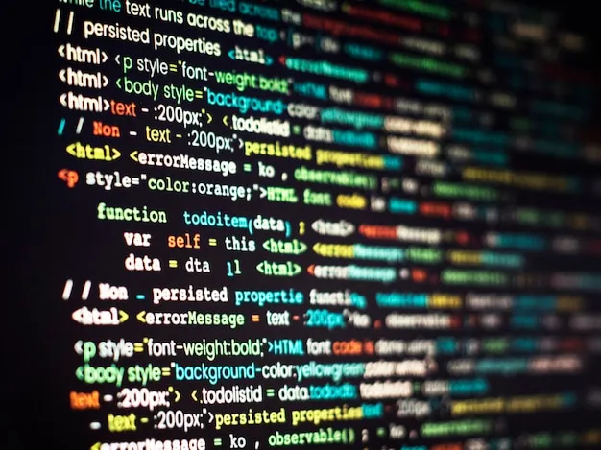

Programming languages is bridge the gap between human and machine execution.

Syntax: the set of rules that define the correct structure of a program
Semantics: the meaning of the instruction
Compiler / interpreter: converts code into machine understandable format.

Types of programming languages

1-based on machine interaction
a) low level languages : directly interact whit hardware
b) high level languages: closer to human languages
2- based on execution method
a)compiled languages : convert entire code into machine code
b) interpreted languages : execute code line by line during runtime
c) hybrid : first compiled into intermediate code and interpreted runtime
3-based on programming paradigm

C# programming language
C# is both compiled and interpreted
1 portability
-code can run on any system with .net runtime CLR
2-performance optimization
- optimizes machine code based on the system hardware
3-security
It undergoes security checks in the CLR before executing
4- dynamic features
-Allow executing dynamic expressions efficiently

Integrated development environment
Software application that provides developers with comprehensive set of tool test debug and deploy code
Key features of IDE
1-Code editor
2- compiler / interpreter
3- debugger
4-Build automation
5-Version control integration
6-Project management
Popular IDE
- visual studio
- IntelliJ
-eclipse
-VS code
Importance of IDE in Software development
1-Boosts productivity
2-Reduces errors
3-Enhances collaboration
4-Supports multiple languages

